1.Write a Pandas program to select the distinct department id from employees file.
code:
import pandas as pd
df = pd.read_csv("employees.csv")
print("Distinct Department IDs:")
print(df["department_id"].drop_duplicates())
output:
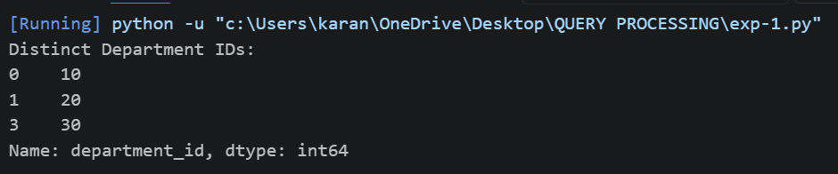
2. Write a Pandas program to display the IDs of employees who have done two or more
Code:
import pandas as pd
df = pd.read_csv("jobhistory.csv")
result = df.groupby("employee_id").size()
print("Employees with two or more jobs:")
print(result[result >= 2])
Output:
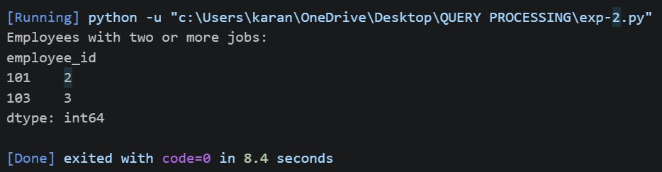
3.Write a Pandas program to display the details of jobs in descending sequence on job title.
Code:
import pandas as pd
df = pd.read_csv("jobs.csv")
result = df.sort_values(by="job_title", ascending=False)
print(result)
Output:
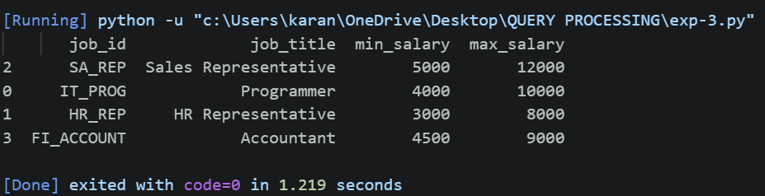
4.Write a Pandas program to create a line plot of the historical stock prices of Alphabet Inc. between two specific dates.
Code:
import pandas as pd
import matplotlib.pyplot as plt
df = pd.read_csv("Alphabet.csv")
df["Date"] = pd.to_datetime(df["Date"])
data = df[(df["Date"] >= "2024-01-01") &
(df["Date"] <= "2024-01-05")]
plt.plot(data["Date"], data["Close"], marker="o")
plt.title("Alphabet Stock Prices")
plt.xlabel("Date")
plt.ylabel("Closing Price")
plt.grid(True)
plt.show()
Output:
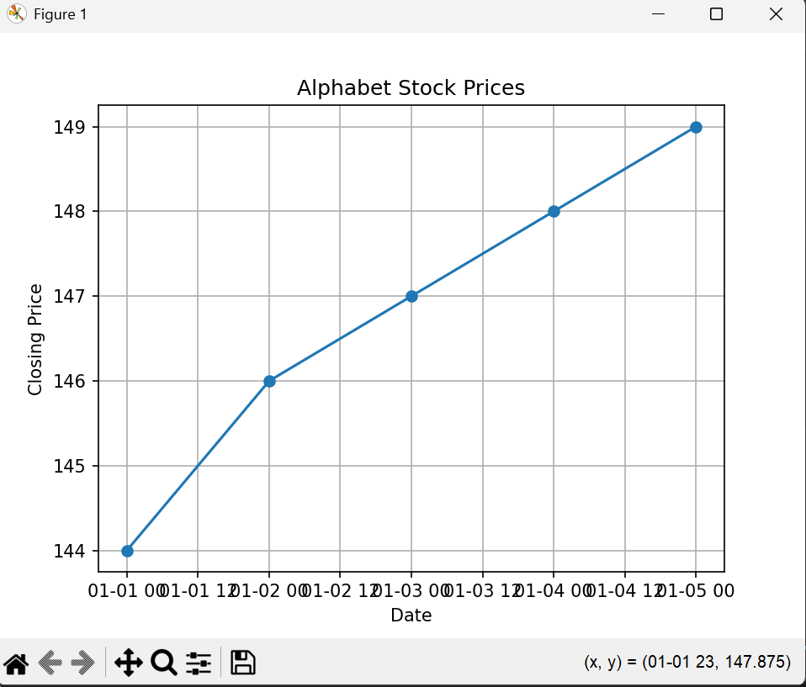
5.Write a Pandas program to create a bar plot of the trading volume of Alphabet Inc.
stock between two specific dates.
Code:
import pandas as pd
import matplotlib.pyplot as plt
df = pd.read_csv("Alphabet.csv")
df["Date"] = pd.to_datetime(df["Date"])
data = df[(df["Date"] >= "2024-01-01") &
(df["Date"] <= "2024-01-05")]
plt.bar(data["Date"].dt.strftime("%Y-%m-%d"), data["Volume"])
plt.title("Trading Volume")
plt.xlabel("Date")
plt.ylabel("Volume")
plt.xticks(rotation=45)
plt.show()
Output:
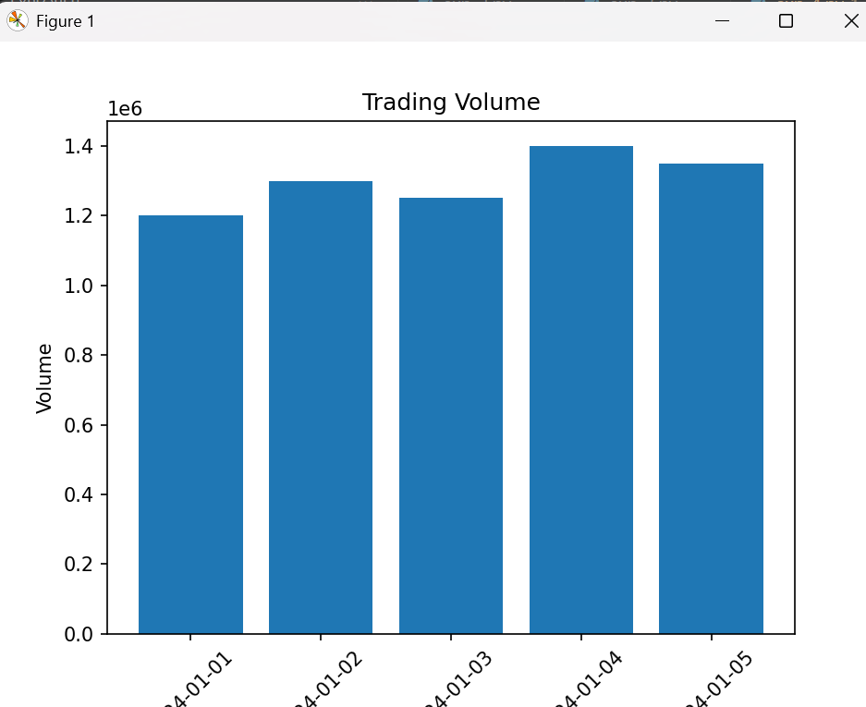
6.Write a Pandas program to create a scatter plot of the trading volume/stock prices of
Alphabet Inc. stock between two specific dates.
Code:
import pandas as pd
import matplotlib.pyplot as plt
df = pd.read_csv("Alphabet.csv")
df["Date"] = pd.to_datetime(df["Date"])
data = df[(df["Date"] >= "2024-01-01") &
(df["Date"] <= "2024-01-05")]
plt.scatter(data["Volume"], data["Close"])
plt.title("Trading Volume vs Closing Price")
plt.xlabel("Volume")
plt.ylabel("Closing Price")
plt.grid(True)
plt.show()
Output:
